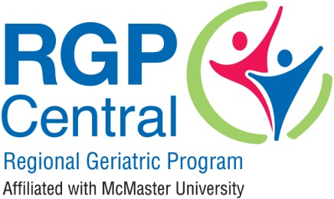
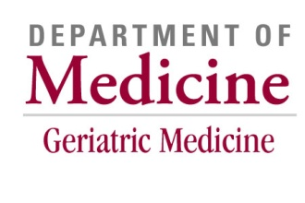
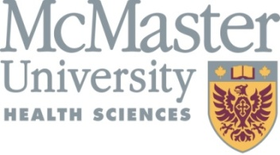

GERIATRIC EDUCATION BURSARY
Division of Geriatric Medicine and Regional Geriatric Program central Education Priorities

Strategic Priorities, Division of Geriatric Medicine, McMaster University:
“[I]ncreasing the presence of the division to ensure the older adult’s ‘voice’ is being heard at all times; enhancing innovation in education, promoting Geriatric Medicine and it’s research and educational initiatives both internally and externally to meet the needs of our patients and community partners; and building strong internal and external collaborations to implement identified goals related to clinical service, education and research.” – https://healthsci.mcmaster.ca/medicine/division/geriatric
Principle statement, Regional Geriatric Program central (RGPc):
“Evidence-based practices must be included in consideration of any models of care, education and research.” – https://rgpc.ca/about-rgpc/
What is the Geriatric Educational Bursary?
The bursary will provide funding to attend geriatric focused educational events and/or courses to support learning needs and goals.
Who is Eligible?
- Health care providers currently working or intending to work in a geriatric setting or medical residents with an interest in geriatrics as a profession.
- Applicants working in the Hamilton Niagara Haldimand-Norfolk Brant, Waterloo Wellington and Mississauga Halton regions.
Bursary Amount
- Two educational bursaries up to a maximum of $500.00 each will be awarded each year.
Timeline & Application Process
- Applications will be accepted between October 5th and November 30th, 2020.
- Submission requirements:
  - Completed application form
  - Statement of needs/plans
- Bursary winners will be notified by mid-December.
- Funds may only be used over the course of the following calendar year (January 1, 2021-December 31, 2021)

More Information: Michelle Doherty, Education Coordinator, RGPc / doherty@hhsc.ca / 905-777-3837, ext. 12436
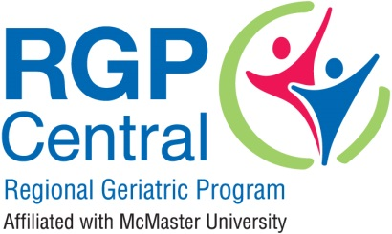

GERIATRIC EDUCATIONAL BURSARY
APPLICATION FORM

APPLICANT INFORMATION

First Name Last Name Title/Position

Organization Name Program/Department

Street Number Street Name City Postal Code

Telephone Ext. Email address

Applicant Signature

Email or mail completed application form and statement of need to:
Attn: Michelle Doherty, Education Coordinator
Regional Geriatric Program central
Juravinski Research Centre
St. Peter’s Hospital
88 Maplewood Avenue
Hamilton ON L8M 1W9
Email: doherty@hhsc.ca

Note: Incomplete or late applications will not be considered.

GERIATRIC EDUCATIONAL BURSARY
STATEMENT OF NEED/PLANS
*If you require more space, please attach additional pages.

Please outline how this bursary will support your professional geriatric education learning goals.

Please describe how the geriatric knowledge and skills that you gain will be shared in your work setting.

