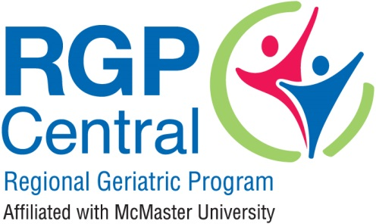
Specialized Geriatric Services (SGS) Grants for Quality Improvement

Grant Application
2019/2020

Section A: Eligibility Criteria

Please complete the following questions before proceeding to complete remaining sections of this application form. If you answer no to any of the following questions your project may not be eligible for funding. If you have questions about the eligibility of your project please contact:
Jennifer Siemon- siemonj@hhsc.ca

Criteria | Eligibility
Are you a frontline, clinical, professional or administrative staff member working in SGS? | Yes No
Has your immediate leader given his/ her support for this project? | Yes No
Do you have the support of a geriatric specialist within your setting (or a physician with Care of the Elderly certification or other specialized training in geriatrics?) | Yes No
Does your project intend to improve quality of service? | Yes No
Does your project target or impact frail seniors over 65-years of age? | Yes No
Are you able to complete your project within your budget request? | Yes No
If no, do you have an established funding source to cover costs exceeding your request? Please note a maximum amount of $10,000.00 may be awarded. If your budget exceeds this amount, please describe from where and how much funding you have or will receive. | Yes No
Does your project include an evaluation process – a method of assessing whether stated objectives were achieved? | Yes No
Are you able to complete your project by April 30, 2020? | Yes No

Section B: Applicant Information

Date:
Principal Applicant Name:
Applicant Title:
Program within SGS:
Site/ Workplace:
Telephone Number/Extension:
Email:
Immediate Leader who has provided support for this project:
Immediate Leader email address:
Geriatric specialist/ physician who has provided support for this project:
Geriatric specialist/ physician email address:
List any Co-applicants and provide their email address.
Do you have an REB? Yes or No. If no, why not.

Section C: Project Information

Please provide to information on each section in 250 words or less.

Project Title:

Briefly describe your idea to improve quality.

Why is this project important? What is the rationale for this project?

What are you trying to accomplish? What will be achieved with this project? Please be specific about what you anticipate the outcomes will be.

How will you do this? Please be specific about what you plan to do in this project.

Does this project directly involve patients? If yes, please describe how many and who these patients will be (age, gender, health status).

Does this project directly involve SGS staff? If yes, please describe how many and who these staff members are and what they are expected to do as part of this project.

Does this project require the purchase of special equipment or materials? If yes, please describe.

How will you measure success? Please be specific about how you will demonstrate that you have achieved your stated objectives (e.g., improved functional status as measured by Functional Independence Measure; patient satisfaction as measured in a patient satisfaction survey; staff perceptions as measured in a survey or interview).

Timeline: Please identify key activities/ components of your project and when you plan to complete them, within the context of the 6 months available for this project (e.g., Task A: Months 1-3, Task B: Months 4 -6)

Plans for dissemination of the results: Please describe how you plan to share the results or apply them within or outside of SGS.

Is there anything else about this project that you would like to describe?

Section D: Project Budget
Provide a detailed budget itemizing how the requested funding will be utilized. Include all associated cost estimates (personnel, materials, professional services)
Budget Item (Add extra rows as needed) | Cost
 | $
 | $
 | $
 | $
 | $
Total Cost (up to $10,000) | $
Will this project result in any additional costs or resources for SGS or your workplace setting? For example, will you use resources from other hospital departments such as pharmacy, laboratory services, radiology etc)?
- No
- Yes, please describe:

Has additional funding been sought from another source for this project? If so, please provide details.

